**Social Media - YouTube - Chat GTP**

Braintrust - Contact Stacking

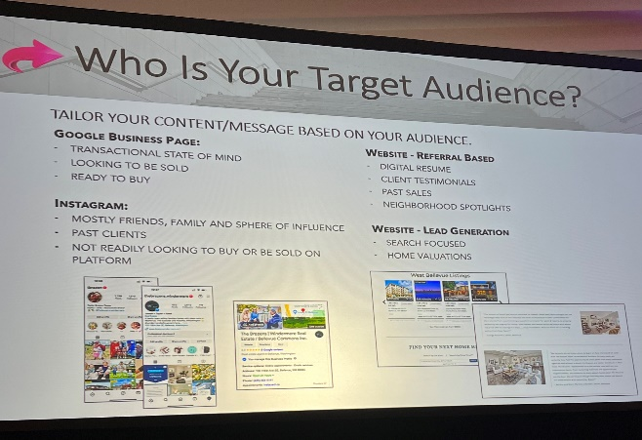

**Social Media** – consistency is the key

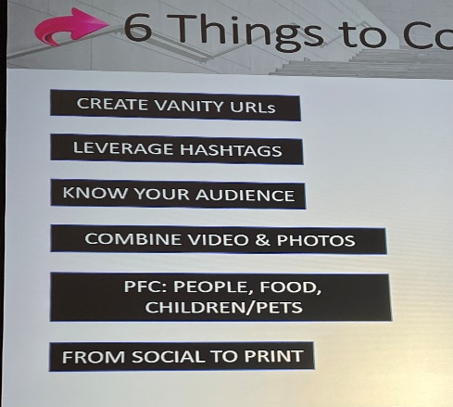

Tell the story of how they bought or sold a home. Don’t just post photos with just sold. People in the photos get more views and stories keep them on your post longer which helps your post get more eyeballs from social media

When you post include one video and 3 photos to keep your post above the fold

*social into print. Print photo and send to them. They love getting a real photo of things that are important to them like their kids and dogs because no one gets real photos anymore.

Instagram- when they view your post reach out to them like you do on Facebook

Best time to post:

* FB 9-3 weekdays
* Insta 10-3 and 7-9 weekdays
* Tic Tok 6-10pm & weekends Sat. evening

Facebook forms work well

Post one video per week

Two Minute Tuesday – a video tip

360 cameras are awesome

Make more community post with great photos that are share worthy. Beautiful sites in your town

If you use to many hashtags on Instagram they will not show your post. Under 15

Use has tags that don’t have thousands of use or no one will see your post. Google has tags for real estate, city, neighborhood, always #the neighborhood you sold in

Follow Katie Lance, Brendan Kane has I mil followers.

Do a video on shorts thanking clients who buy or list.

Private messaging a post will help it go viral

FB wants to grow reels and stories, if you use them, they will give you more views

**YouTube**

*Follow Jerry Pinkas Myrtle Beach. YouTube pays him 50k a year to post. 95,000 subscribers.

Post one video per week. Consistency is the single most important thing you can do.

Videos – always shoot vertical and horizontal for social media

Create your Avatar, remember content must answer WIFM, use a hook, get repeat viewers by making a joke to let you and your personality be known. Reply to all comments.

Questions in the title. Put your same questions in the description. In the title writing create curiosity. Such as: a secret, powerful tool, a negative that turned out positive.

Numbers in the title grab attention. 15 tips on how to avoid X or get X. 5 things this buyer did wrong. Every video needs to start with a hook

In your contact information link to other related videos you have made

Start with a 30 second hook. Here are 5 things, 13 things, numbers really work. Fear of loss makes them keep watching to get all the points.

Jump cuts keep attention.

Choose a topic with helpful information.

***Opus – takes long videos and turns them into shorts

“Making this video for you” give me a thumbs up if you like it. (gets more subscribers)

Post 3 to 5 of the same subject matters/topics in a row to trigger the algorithm.

Videos that blew up the phone –

*I am going to let you in on a secret to owning a home with low or no cash. I don’t know why no one is getting this information out but I am today. The best secret is an FHA mortgage. FHA mortgages only require 3.5% downpayment and seller can pay buyer closing cost. Or if you are willing to move about 30 minutes outside of any major city you can buy a home with zero down payment and seller can still pay buyers closing cost. Don’t let your dreams get kicked to the curb. Call me for the details. I can help you own a home with low cash or no cash out of your pocket. If this video was helpful give me a thumbs up*

Referral video – *deals happen about once a week, but you need an experienced agent who knows how to find them. If you are looking for a deal anywhere in the US, I can help connect you to the right agent that knows where the deals are in their market.*

Need: Videorama, typorama, teleprompter, layouts

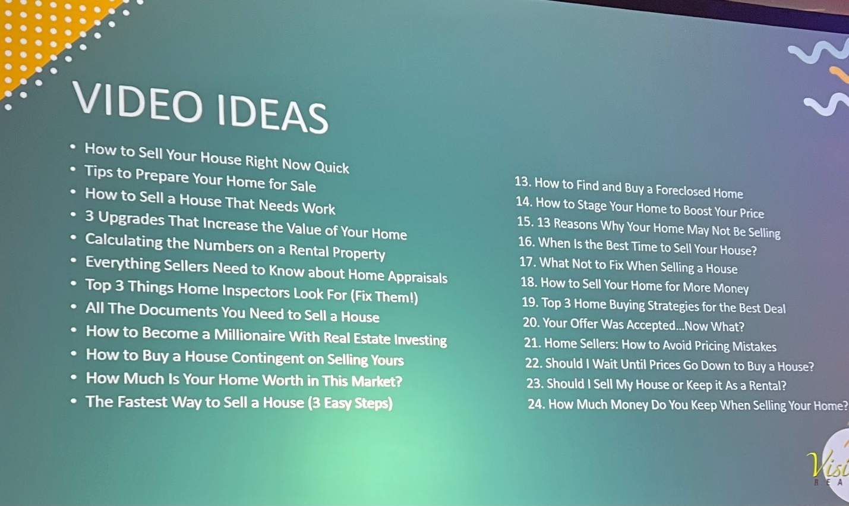

**Chat GTP AI**

Tips for Getting Started with ChatGPT

1. **Access ChatGPT:** open a browser and type in chat.openai.com then follow the prompts to sign up.
2. **Begin the Conversation:** Start typing to initiate a conversation with ChatGPT. This could be a question, statement, or task.
3. **Be Specific and Clear:** Ensure your prompts are as specific and clear as possible to get the most accurate responses.
4. **Use Context:** Utilize the model's ability to understand and remember the context.
5. **Request Edits or Rewrites:** If you're not satisfied with the response, ask the model to provide more information, explain differently, or rephrase the response.
6. **Prompt Creatively:** For creative tasks, use detailed prompts to guide the output.
7. **Experiment:** Try different questions and prompts to learn about ChatGPT's strengths and limitations.
8. **Use Safely and Responsibly:** Do not share personal, sensitive, or confidential information with the model and use the tool responsibly.

The prompt is everything. If you don’t get what you want prompt again.

These words make ChatGPT better: compelling, friendly, professional, playful, informative, conversational, funny, luxurious

1. Ask AI to write your social calendar or give you ideas to post.
2. If you have a list of things to tell someone you can ask AI to turn your list into questions
3. If you have not followed up with a lead in 2 years ask AI what to say
4. Calling around your listings as AI what to say
5. If you don’t know what to say…ask AI
6. Can be prompted to create numbered tables
7. When prompt comes back ask for more information. Ask to make it more professional or friendly. Even can ask for a NC language.
8. Have it write your bio. Send a top producer’s bio or social description and ask AI to make it better for you.
9. Can fix language barriers.

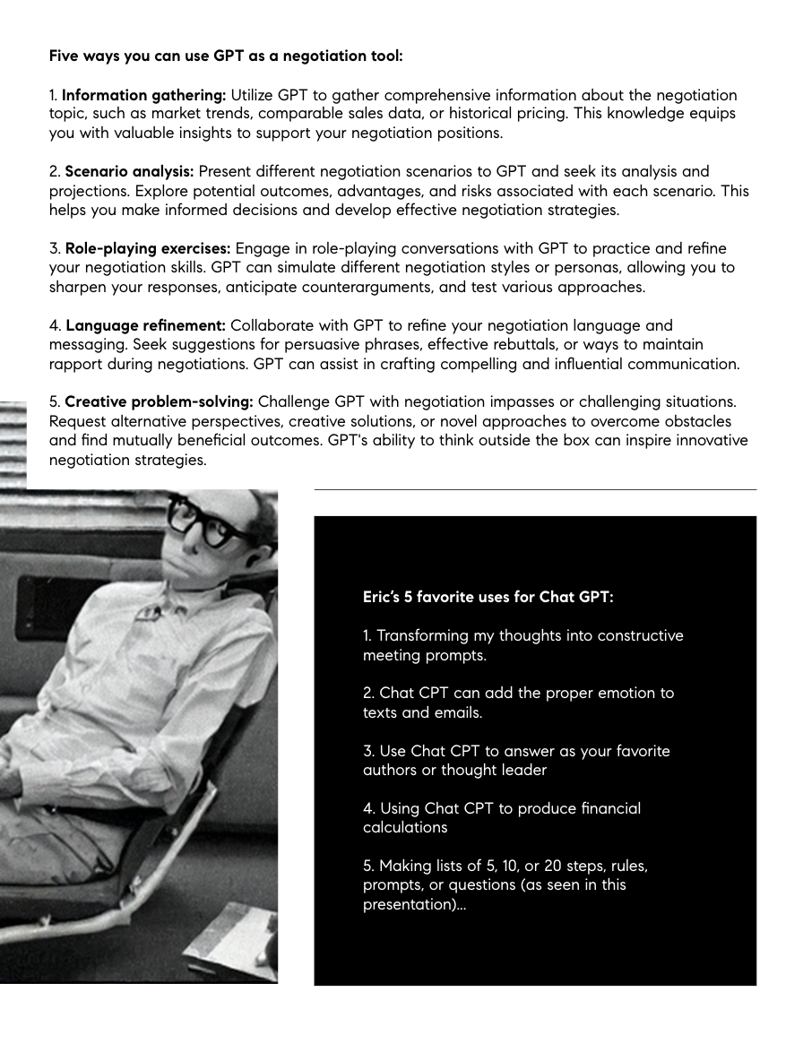

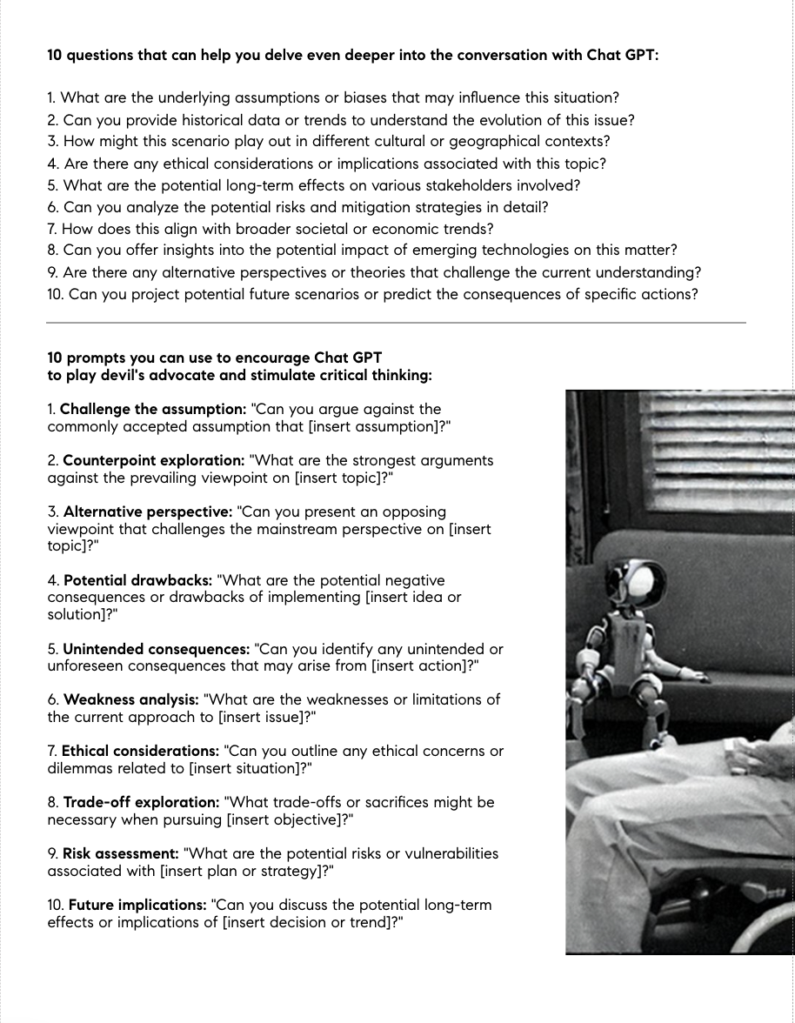

TRIPNOTES.ai

Answerthepublic.com (ask a question to see what the public is searching for)

Grammarly – writing assistant

BARD

RPR uses ChatGPT to write the market update

Canva on top right hand corner has training videos on ChatGTP for Realtors

**C: Client attraction**

Lead generation is a way ChatGPT can be utilized to provide content that attracts [your ideal, targeted client](https://nam04.safelinks.protection.outlook.com/?url=https%3A%2F%2Fwww.inman.com%2F2023%2F03%2F20%2Fquiz-whos-your-perfect-client%2F&data=05%7C01%7Clc%40lindacraft.com%7Ca5c5bf763fc54affe0ff08db8eb0243f%7Cce0b4d91efa6438c807544cc84530985%7C0%7C0%7C638260659408638878%7CUnknown%7CTWFpbGZsb3d8eyJWIjoiMC4wLjAwMDAiLCJQIjoiV2luMzIiLCJBTiI6Ik1haWwiLCJXVCI6Mn0%3D%7C3000%7C%7C%7C&sdata=f207x3CXfJkbw9D7EvBY6fLEeEYQULmN13M04qm%2B0II%3D&reserved=0). The following are 14 promptings to create client attraction content.

**1.** Give me an SEO-optimized [whatever platform you choose] [post or video script] with 5 reasons people love moving from [feeder market for your area] to [your city]. This prompt is designed to attract buyers moving into your area from a feeder market.

**2.** Give me an SEO-optimized [whatever platform you choose] [post or video script] with 7 reasons buying a home is smarter than renting in [your city]. This content is designed to attract first-time homebuyers.

**3.** Give me an SEO-optimized [whatever platform you choose] [post or video script] with 5 things renters wish they would have known before buying a home in [your city].

**4.** Give me an SEO-optimized [whatever platform you chose] [post or video script] with 7 Things Every Homeowner Should Do Before Listing Their Home For Sale in [your city]. This one is focused on capturing the attention of homeowners early in the process of listing their home for sale.

**5.** Give me an SEO-optimized [whatever platform you choose] [post or video script] with the 5 [biggest mistakes](https://nam04.safelinks.protection.outlook.com/?url=https%3A%2F%2Fwww.inman.com%2F2023%2F03%2F16%2F7-reasons-agents-are-failing-and-how-to-avoid-their-mistakes%2F&data=05%7C01%7Clc%40lindacraft.com%7Ca5c5bf763fc54affe0ff08db8eb0243f%7Cce0b4d91efa6438c807544cc84530985%7C0%7C0%7C638260659408638878%7CUnknown%7CTWFpbGZsb3d8eyJWIjoiMC4wLjAwMDAiLCJQIjoiV2luMzIiLCJBTiI6Ik1haWwiLCJXVCI6Mn0%3D%7C3000%7C%7C%7C&sdata=9YN17APgA7BolKFJpje1tn8YbJrBkpikqgrXZ5zy3%2FQ%3D&reserved=0) homeowners in [your city] make before listing their home for sale including #5 being not calling [your name] earlier. This is another prompting focused on people preparing to sell their home soon.

**6.** Give me an SEO-optimized [whatever platform you choose] [post or video script] with the 7 biggest regrets homeowners in [your city] have after listing their home for sale including the 7th one not calling [you]. This one is focused on attracting potential listing clients.

**7.** Give me an SEO-optimized [whatever platform you choose] post or video script with 7 things divorcees should do before listing their home for sale in [your city] with number seven being calling [you] sooner. This is focused on a specific demographic that often needs to sell due to the life event of divorce.

**8.** Give me an SEO-optimized [whatever platform you choose] post or video script with 7 Ways Executors of Estates Can Leverage Real Estate Agents to Make Their Job Easier in [your city] with number seven being to call [you]. Another prompting focused on executors of estates going through probate with the need to sell a home due to the life event of the owner’s death.

**9.** Give me an SEO-optimized [whatever platform you choose] post or video script with 7 things empty nesters should consider before downsizing and listing their home for sale in [your city] with number seven being to call [you]. This prompting is focused on attracting clients considering downsizing.

**10.** Give me an SEO-optimized [whatever platform you choose] post or [video script](https://nam04.safelinks.protection.outlook.com/?url=https%3A%2F%2Fwww.inman.com%2F2023%2F05%2F18%2F5-types-of-realtor-videos-that-put-passive-prospecting-on-autopilot%2F&data=05%7C01%7Clc%40lindacraft.com%7Ca5c5bf763fc54affe0ff08db8eb0243f%7Cce0b4d91efa6438c807544cc84530985%7C0%7C0%7C638260659408638878%7CUnknown%7CTWFpbGZsb3d8eyJWIjoiMC4wLjAwMDAiLCJQIjoiV2luMzIiLCJBTiI6Ik1haWwiLCJXVCI6Mn0%3D%7C3000%7C%7C%7C&sdata=KJdt%2BuGTggwUA1cdrNofq2Bc68c0dYtKXZUHJnrRuJs%3D&reserved=0) with 7 things engaged couples should consider before buying a home in [your city]. This prompting is focused on attracting clients with the life event of engagement that often leads to the purchase of a home.

**11.** Give me an SEO-optimized [whatever platform you choose] post or video script with how a growing family in [your city] can buy a home without breaking the bank. Couples that are expecting are often faced with the need to either buy a home or buy a bigger home than the one they currently own.

**12.** Give me an SEO-optimized [whatever platform you choose] post or video script with 7 reasons buying a home while stationed at [military base] makes more sense than renting. This is focused on attracting military personnel with permanent change of station [PCS] orders.

**13.** Give me an SEO-optimized [whatever platform you choose] post or video script with 7 reasons selling your home in [your city] during the [season of the year] can be opportunistic. This one is specifically designed to attract listings in a specific season of the year.

Advertisement

**14.** Give me an SEO-optimized [whatever platform you chose] post or video script with 7 reasons buying a home in [your city] during the [season of the year] season could be advantageous. Specifically targeted messaging to attract buyers in a specific season of the year.

**H: Help with social media optimization**

Social media is one of the most effective ways to [attract new clients](https://nam04.safelinks.protection.outlook.com/?url=https%3A%2F%2Fwww.inman.com%2F2023%2F05%2F16%2F9-ways-to-get-new-clients-without-having-to-door-knock%2F&data=05%7C01%7Clc%40lindacraft.com%7Ca5c5bf763fc54affe0ff08db8eb0243f%7Cce0b4d91efa6438c807544cc84530985%7C0%7C0%7C638260659408638878%7CUnknown%7CTWFpbGZsb3d8eyJWIjoiMC4wLjAwMDAiLCJQIjoiV2luMzIiLCJBTiI6Ik1haWwiLCJXVCI6Mn0%3D%7C3000%7C%7C%7C&sdata=K0mhislBKwlVP2bSpmIKL7BRo%2F%2BzyhPpTAV8gQTYc%2FE%3D&reserved=0) in today’s market environment. The following are ways to make sure you take full advantage of the opportunities social media presents.

**15.** Give me an SEO-optimized Instagram Profile for [your name], a Realtor in [your city] with the following accolades and designations.

**16.** Give me an SEO-optimized LinkedIn profile for [your name], a Realtor in [your city] with the following accolades and designations.

**17.** Give me an SEO-optimized Facebook profile for [your name], a Realtor in [your city] with the following accolades and designations.

**18.** Give me an SEO-optimized YouTube page description for a [YouTube Channel](https://nam04.safelinks.protection.outlook.com/?url=https%3A%2F%2Fwww.inman.com%2F2023%2F01%2F23%2F23-binge-worthy-real-estate-youtube-channels%2F&data=05%7C01%7Clc%40lindacraft.com%7Ca5c5bf763fc54affe0ff08db8eb0243f%7Cce0b4d91efa6438c807544cc84530985%7C0%7C0%7C638260659408638878%7CUnknown%7CTWFpbGZsb3d8eyJWIjoiMC4wLjAwMDAiLCJQIjoiV2luMzIiLCJBTiI6Ik1haWwiLCJXVCI6Mn0%3D%7C3000%7C%7C%7C&sdata=JyOqGn3EXbtSajC%2BdyV1TWTOx9v3ymLQXJzm3zCuzp8%3D&reserved=0) for [your name], a Realtor in [your city] with videos and content focused on helping [whoever your ideal client is].

Advertisement

**19.** Give me an SEO-optimized Facebook post for the home located at [address] with the following MLS description [drop in the MLS description]. This is a prompt we utilized that has increased our Facebook engagement by an average of more than 20 percent since beginning to use it less than a month ago.

**20.** Right after it gives you the SEO-optimized Facebook post, say convert this to an SEO-optimized Instagram post including hashtags.

**21.** Right after it gives you the SEO-optimized Instagram post, say convert this to an SEO-optimized [Instagram Reel](https://nam04.safelinks.protection.outlook.com/?url=https%3A%2F%2Fwww.inman.com%2F2022%2F11%2F21%2Fdont-understand-instagram-heres-what-you-need-to-know-in-45-seconds%2F&data=05%7C01%7Clc%40lindacraft.com%7Ca5c5bf763fc54affe0ff08db8eb0243f%7Cce0b4d91efa6438c807544cc84530985%7C0%7C0%7C638260659408638878%7CUnknown%7CTWFpbGZsb3d8eyJWIjoiMC4wLjAwMDAiLCJQIjoiV2luMzIiLCJBTiI6Ik1haWwiLCJXVCI6Mn0%3D%7C3000%7C%7C%7C&sdata=YdyfPQcnOFL9EfVzcrFPgGYMnw1SUjC3p7SE9Hcud%2FY%3D&reserved=0) video script.

**22.** Give me an SEO-optimized 1,000-word LinkedIn article for the home located at [address] with the following MLS description [drop in the MLS description].

**A: Answering the tough questions**

If you have questions that you’re not sure how to answer or if buyers or sellers are saying they are waiting to make a move based on an event, then ChatGPT has the answers. Here are a few promptings to turn obstacles into opportunities.

**23.** Give me an SEO-optimized [Facebook post](https://nam04.safelinks.protection.outlook.com/?url=https%3A%2F%2Fwww.inman.com%2F2022%2F08%2F17%2Fis-your-facebook-page-a-ghost-town-5-mistakes-that-scare-off-clients%2F&data=05%7C01%7Clc%40lindacraft.com%7Ca5c5bf763fc54affe0ff08db8eb0243f%7Cce0b4d91efa6438c807544cc84530985%7C0%7C0%7C638260659408638878%7CUnknown%7CTWFpbGZsb3d8eyJWIjoiMC4wLjAwMDAiLCJQIjoiV2luMzIiLCJBTiI6Ik1haWwiLCJXVCI6Mn0%3D%7C3000%7C%7C%7C&sdata=8DIPFliliE%2B1istom8tqMIUJZIbvu8cPif7ZrJUYQSw%3D&reserved=0) with 5 reasons a potential homebuyer should consider buying a home in [your city] despite an increase in interest rates.

Advertisement

**24.** Give me an SEO-optimized Facebook post with 3 reasons buying a home in [your city] right now is smart even though home prices have gone up over the last few years.

The following steps are a way to compound the content once we are answering the tough questions.

**25.** The next thing to do once it provides the above Facebook posts is to ask it to convert the Facebook posts into 1,000-word SEO-optimized LinkedIn articles.

**26.** Then ask it to convert the above [LinkedIn](https://nam04.safelinks.protection.outlook.com/?url=https%3A%2F%2Fwww.inman.com%2F2022%2F10%2F11%2F7-reasons-you-should-seriously-reconsider-linkedin%2F&data=05%7C01%7Clc%40lindacraft.com%7Ca5c5bf763fc54affe0ff08db8eb0243f%7Cce0b4d91efa6438c807544cc84530985%7C0%7C0%7C638260659408638878%7CUnknown%7CTWFpbGZsb3d8eyJWIjoiMC4wLjAwMDAiLCJQIjoiV2luMzIiLCJBTiI6Ik1haWwiLCJXVCI6Mn0%3D%7C3000%7C%7C%7C&sdata=hfkB%2FAEPJNEXRV%2BNoZxV6nWcsR%2BVoxctXmC%2BK9T5VPg%3D&reserved=0) articles into SEO-optimized Instagram post including hashtags.

**27.** Then ask it to convert the above Instagram post into an SEO-optimized video script for an Instagram Reel. This script could be used for a video for TikTok or a YouTube Short as well.

**T: Taking your listing presentation to the next level**

Imagine walking into a listing presentation with multiple, well-written [MLS descriptions](https://nam04.safelinks.protection.outlook.com/?url=https%3A%2F%2Fwww.inman.com%2F2022%2F02%2F23%2F15-ways-your-property-descriptions-could-violate-fair-housing%2F&data=05%7C01%7Clc%40lindacraft.com%7Ca5c5bf763fc54affe0ff08db8eb0243f%7Cce0b4d91efa6438c807544cc84530985%7C0%7C0%7C638260659408638878%7CUnknown%7CTWFpbGZsb3d8eyJWIjoiMC4wLjAwMDAiLCJQIjoiV2luMzIiLCJBTiI6Ik1haWwiLCJXVCI6Mn0%3D%7C3000%7C%7C%7C&sdata=6rXfoRh%2Bp8OrAZWAjbaP%2BBoCGspuYeu0zNxlMvi0lFY%3D&reserved=0), SEO-optimized social media posts, and SEO-optimized video scripts. It is possible and only takes a few minutes with ChatGPT. Request the following prompts and share them at your listing appointment to separate yourself from your competition.

Advertisement

**28.** Give me an MLS description for the home located at [address] highlighting [amenities and selling points of the home]. Then ask it to write the description provided in another tone such as: convert this to a more luxury-style description.

**29.** Convert this MLS description into an SEO-optimized Facebook post.

**30.** Convert this Facebook post to an [SEO-optimized](https://nam04.safelinks.protection.outlook.com/?url=https%3A%2F%2Fwww.inman.com%2F2023%2F03%2F22%2Fhow-to-build-an-ever-evolving-blog-and-become-the-local-expert%2F&data=05%7C01%7Clc%40lindacraft.com%7Ca5c5bf763fc54affe0ff08db8eb0243f%7Cce0b4d91efa6438c807544cc84530985%7C0%7C0%7C638260659408638878%7CUnknown%7CTWFpbGZsb3d8eyJWIjoiMC4wLjAwMDAiLCJQIjoiV2luMzIiLCJBTiI6Ik1haWwiLCJXVCI6Mn0%3D%7C3000%7C%7C%7C&sdata=RORFFklLZU4GoTwCKyIi4qMg70yRXFxRWoTYFEK2uHs%3D&reserved=0) Instagram post.

**31.** Convert the MLS description above into an SEO-optimized 1,000-word LinkedIn article.

**32.** Convert this article to an SEO-optimized YouTube video script.

**33.** Convert this script to an SEO-optimized Instagram Reel script.

**G: Generating ideas on how to grow your business**

ChatGPT also provides you with everything you need to generate ideas on growing your business or enhancing your marketing.

**34.** Give me 20 unique ways to market a home for sale with a targeted buyer group of [your targeted buyer profile like first-time homebuyer or investor].

Advertisement

**35.** Give me 20 ways a real estate agent can grow her [social media connections](https://nam04.safelinks.protection.outlook.com/?url=https%3A%2F%2Fwww.inman.com%2F2023%2F04%2F21%2F5-ai-driven-social-media-strategies-real-estate-agents-are-missing%2F&data=05%7C01%7Clc%40lindacraft.com%7Ca5c5bf763fc54affe0ff08db8eb0243f%7Cce0b4d91efa6438c807544cc84530985%7C0%7C0%7C638260659408638878%7CUnknown%7CTWFpbGZsb3d8eyJWIjoiMC4wLjAwMDAiLCJQIjoiV2luMzIiLCJBTiI6Ik1haWwiLCJXVCI6Mn0%3D%7C3000%7C%7C%7C&sdata=fMDVKHWsw5UK1rcNQ5vI3J2tvVL2bMFsDedV1oWYf20%3D&reserved=0) and followers.

**36.** Give me 20 SEO-optimized YouTube video titles that a real estate agent should record to attract business through YouTube.

**37.** Give me 20 ways a real estate agent can uniquely promote his business.

**P: Past client and referral partner appreciation**

**38.** Give me 20 ideas on how a real estate agent can show her appreciation for past clients or referral partners.

**T: Telling your community’s story**

Telling your community’s story is a great way to provide valuable information and set yourself up as the resource for [community information](https://nam04.safelinks.protection.outlook.com/?url=https%3A%2F%2Fwww.inman.com%2F2023%2F03%2F23%2Fsell-your-city-when-you-serve-and-support-your-community%2F&data=05%7C01%7Clc%40lindacraft.com%7Ca5c5bf763fc54affe0ff08db8eb0243f%7Cce0b4d91efa6438c807544cc84530985%7C0%7C0%7C638260659408638878%7CUnknown%7CTWFpbGZsb3d8eyJWIjoiMC4wLjAwMDAiLCJQIjoiV2luMzIiLCJBTiI6Ik1haWwiLCJXVCI6Mn0%3D%7C3000%7C%7C%7C&sdata=fA30yjUcLUtULzci5%2FxzrPicNqXKJlXHgF45Em3S%2BX4%3D&reserved=0).

**39.** Give me an SEO-optimized [whatever platform you choose] [post or video script] with 5 things people don’t know about [your city].

**40.** Give me an SEO-optimized [whatever platform you choose] [post or video script] with 7 interesting facts about [your city].

ChatGPT has opened a window of opportunity that typically only comes a few times during a career. Take advantage of this amazing tool and your business can’t help but grow.